**LAB TASK-10(24K-0555)**

**QUESTION-1A:**  
**CODE:**

#include <stdio.h>

void reverseSentence(char str[], int index) {

if (str[index] == '\0') {

return;

}

reverseSentence(str, index + 1);

printf("%c", str[index]);

}

int main() {

char message[100];

printf("Enter the message: ");

fgets(message, sizeof(message), stdin);

reverseSentence(message, 0);

return 0;

}

**OUTPUT:**

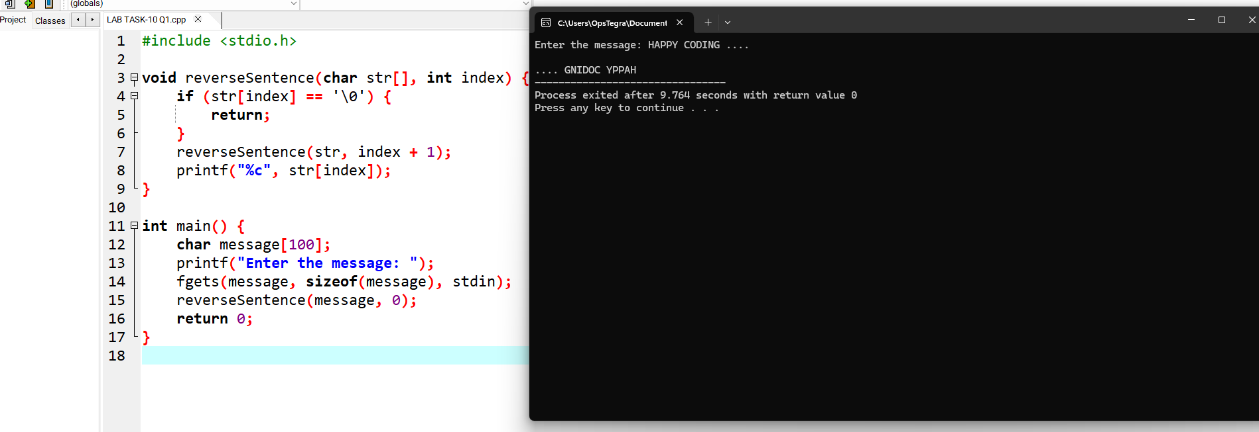

**QUESTION-2:**  
**CODE:**

#include <stdio.h>

void printPercentage(int num, int percent) {

if (percent > 100) {

return;

}

printf("%d%% of %d is %.2f\n", percent, num, (num * percent) / 100.0);

printPercentage(num, percent + 1);

}

int main() {

int num;

printf("Enter the number: ");

scanf("%d", &num);

printPercentage(num, 1);

return 0;

}

**OUTPUT:**

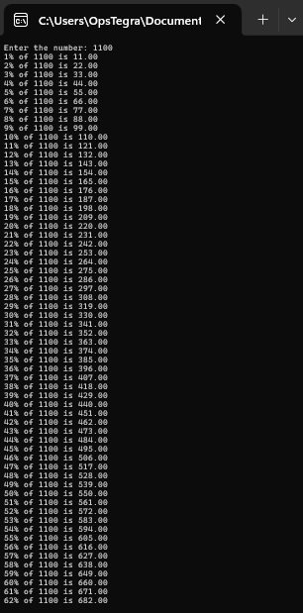

**QUESTION-3:**  
**CODE:**

#include <stdio.h>

struct Car {

char make[50];

char model[50];

int year;

float price;

float mileage;

};

int main() {

struct Car cars[5];

int numCars = 0;

while (1) {

int choice;

printf("\n1. Add Car\n2. Display Cars\n3. Exit\nChoose an option: ");

scanf("%d", &choice);

if (choice == 1) {

printf("Enter car make: ");

scanf("%s", cars[numCars].make);

printf("Enter car model: ");

scanf("%s", cars[numCars].model);

printf("Enter car year: ");

scanf("%d", &cars[numCars].year);

printf("Enter car price: ");

scanf("%f", &cars[numCars].price);

printf("Enter car mileage: ");

scanf("%f", &cars[numCars].mileage);

numCars++;

} else if (choice == 2) {

for (int i = 0; i < numCars; i++) {

printf("\nCar %d: %s %s (%d)\n", i + 1, cars[i].make, cars[i].model, cars[i].year);

printf("Price: %.2f, Mileage: %.2f\n", cars[i].price, cars[i].mileage);

}

} else if (choice == 3) {

break;

}

}

return 0;

}

**OUTPUT:**

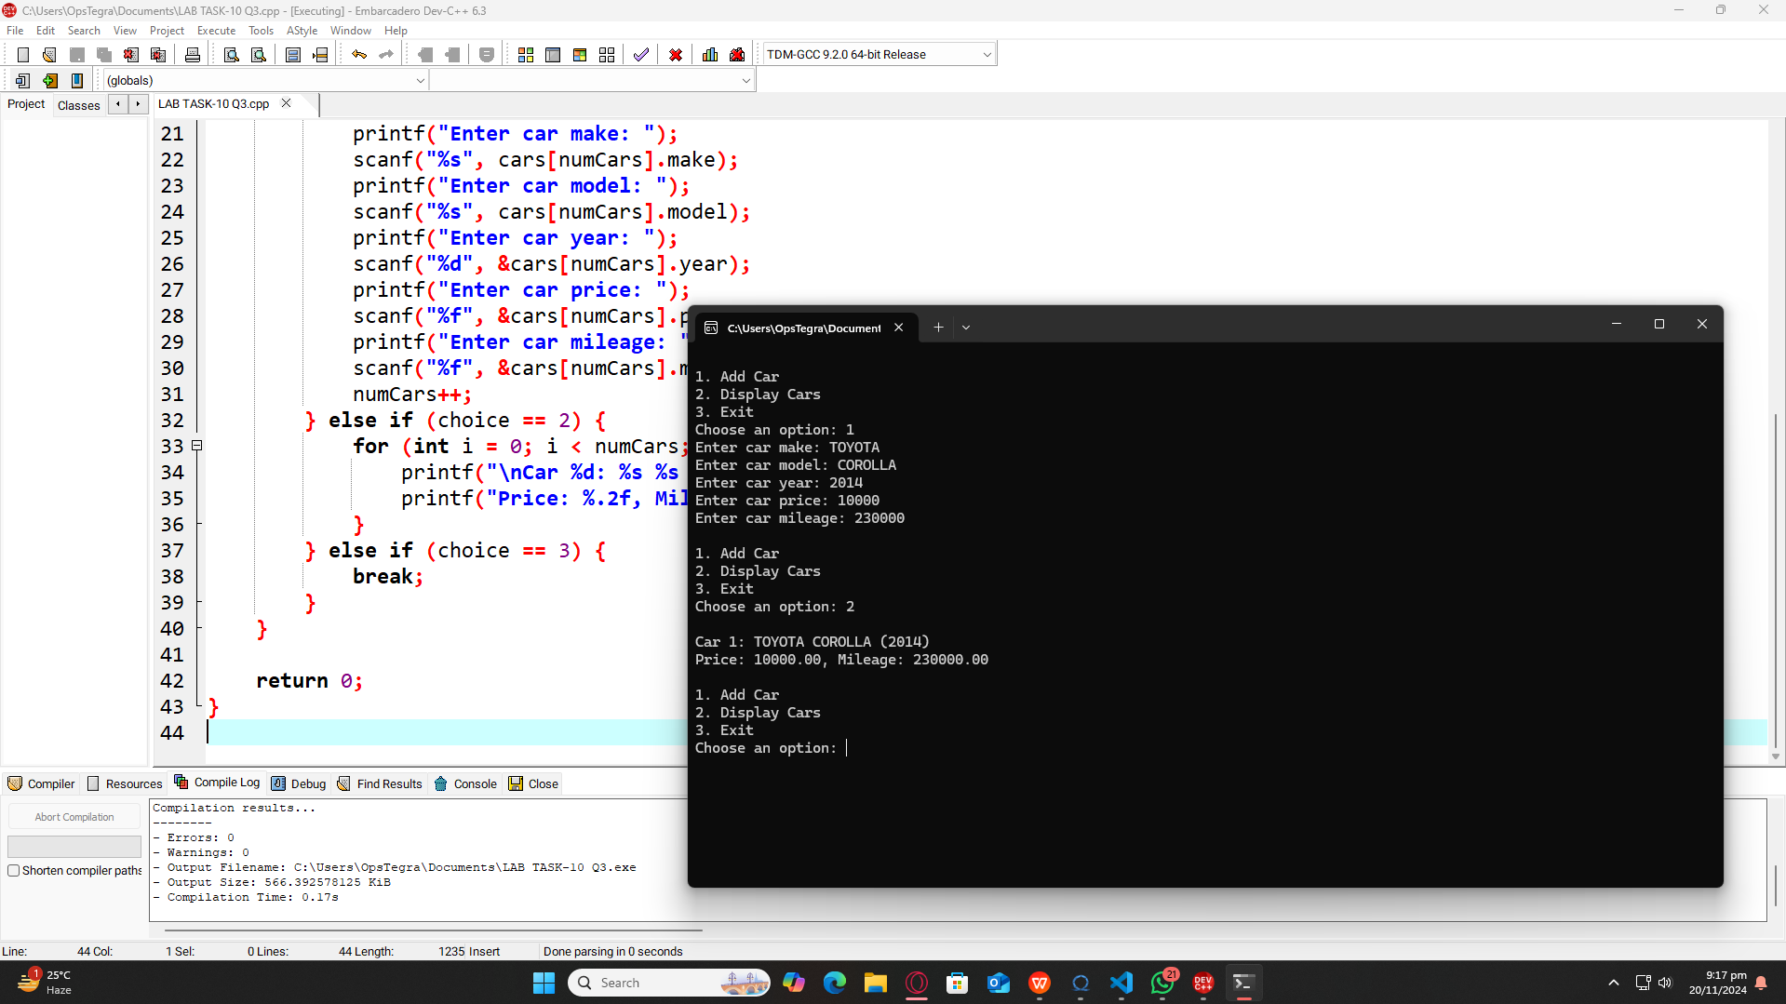

**QUESTION-4:**  
**CODE:**

#include <stdio.h>

#include <string.h>

struct TravelPackage {

char name[50];

char destination[50];

int duration;

float cost;

int seatsAvailable;

};

int main() {

struct TravelPackage packages[5];

int numPackages = 0;

char packageName[50];

while (1) {

int choice;

printf("\n1. Add Package\n2. Display Packages\n3. Book Package\n4. Exit\nChoose an option: ");

scanf("%d", &choice);

if (choice == 1) {

printf("Enter package name: ");

scanf("%s", packages[numPackages].name);

printf("Enter destination: ");

scanf("%s", packages[numPackages].destination);

printf("Enter duration: ");

scanf("%d", &packages[numPackages].duration);

printf("Enter cost: ");

scanf("%f", &packages[numPackages].cost);

printf("Enter available seats: ");

scanf("%d", &packages[numPackages].seatsAvailable);

numPackages++;

} else if (choice == 2) {

for (int i = 0; i < numPackages; i++) {

printf("\nPackage: %s\nDestination: %s\nDuration: %d days\nCost: %.2f\nSeats Available: %d\n", packages[i].name, packages[i].destination, packages[i].duration, packages[i].cost, packages[i].seatsAvailable);

}

} else if (choice == 3) {

printf("Enter package name to book: ");

scanf("%s", packageName);

int booked = 0;

for (int i = 0; i < numPackages; i++) {

if (strcmp(packages[i].name, packageName) == 0 && packages[i].seatsAvailable > 0) {

printf("Booking %s for you.\n", packages[i].name);

packages[i].seatsAvailable--;

booked = 1;

break;

}

}

if (!booked) {

printf("Sorry, no available seats for the package %s.\n", packageName);

}

} else if (choice == 4) {

break;

}

}

return 0;

}

**OUTPUT:**

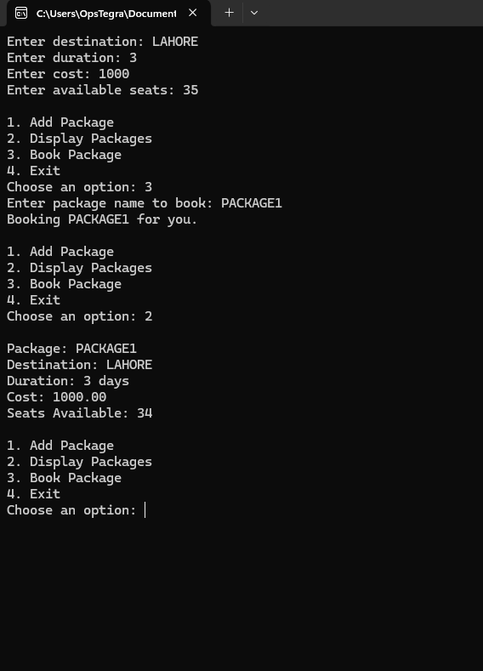

**QUESTION-5:**  
**CODE:**

#include <stdio.h>

int main() {

int num, sum = 0;

printf("Enter a number: ");

scanf("%d", &num);

while (num > 0) {

sum += num % 10;

num /= 10;

}

printf("Sum of digits: %d\n", sum);

return 0;

}

**OUTPUT:**

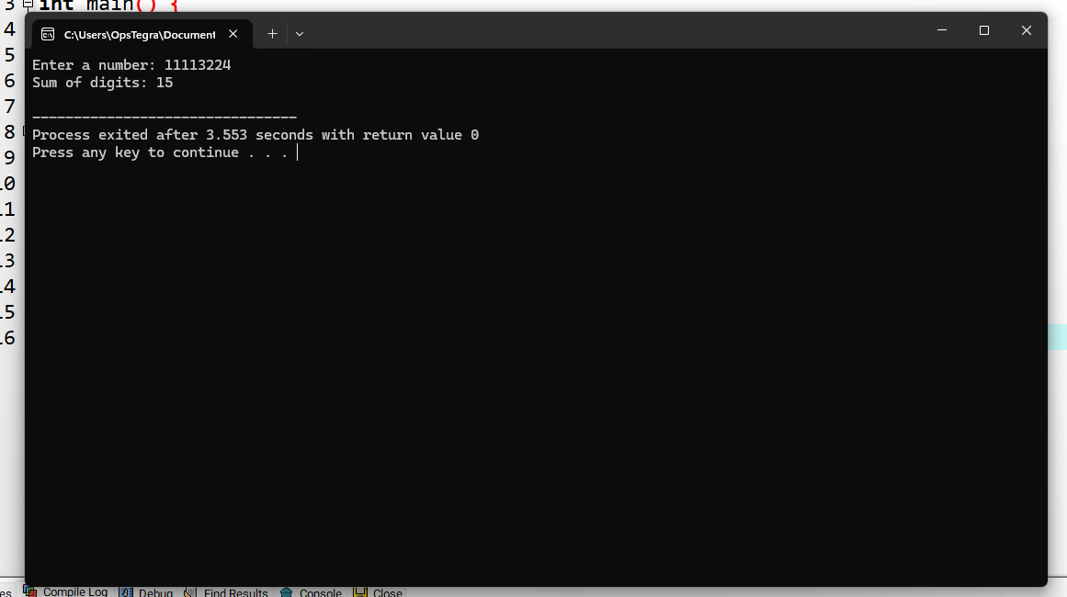

**QUESTION-6:**  
**CODE:**

#include <stdio.h>

#include <string.h>

void reverseString(char str[], int index, int length) {

if (index < length / 2) {

char temp = str[index];

str[index] = str[length - index - 1];

str[length - index - 1] = temp;

reverseString(str, index + 1, length);

}

}

int main() {

char str[100];

printf("Enter a string: ");

fgets(str, sizeof(str), stdin);

str[strcspn(str, "\n")] = '\0';

int length = strlen(str);

reverseString(str, 0, length);

printf("Reversed string: %s\n", str);

return 0;

}

**OUTPUT:**

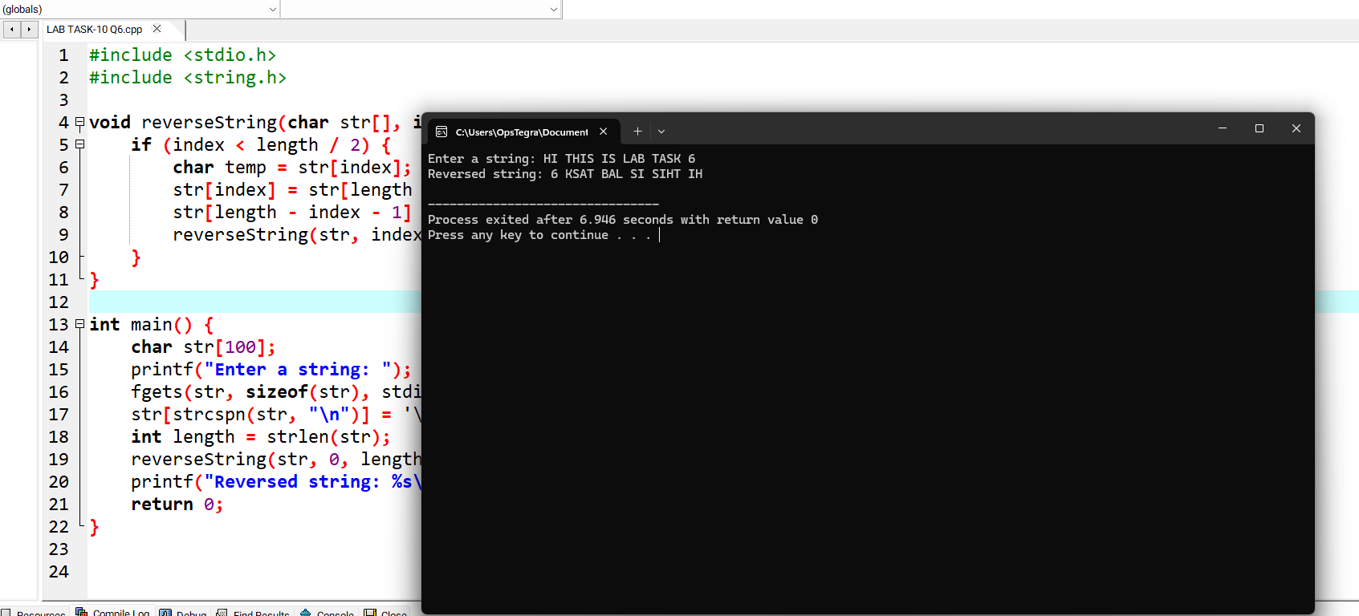

**QUESTION-7:**  
**CODE:**

#include <stdio.h>

void bubbleSort(int arr[], int n) {

if (n == 1) {

return;

}

for (int i = 0; i < n - 1; i++) {

if (arr[i] > arr[i + 1]) {

int temp = arr[i];

arr[i] = arr[i + 1];

arr[i + 1] = temp;

}

}

bubbleSort(arr, n - 1);

}

int main() {

int n;

printf("Enter the number of elements: ");

scanf("%d", &n);

int arr[n];

printf("Enter the elements: ");

for (int i = 0; i < n; i++) {

scanf("%d", &arr[i]);

}

bubbleSort(arr, n);

printf("Sorted array: ");

for (int i = 0; i < n; i++) {

printf("%d ", arr[i]);

}

printf("\n");

return 0;

}

**OUTPUT:**

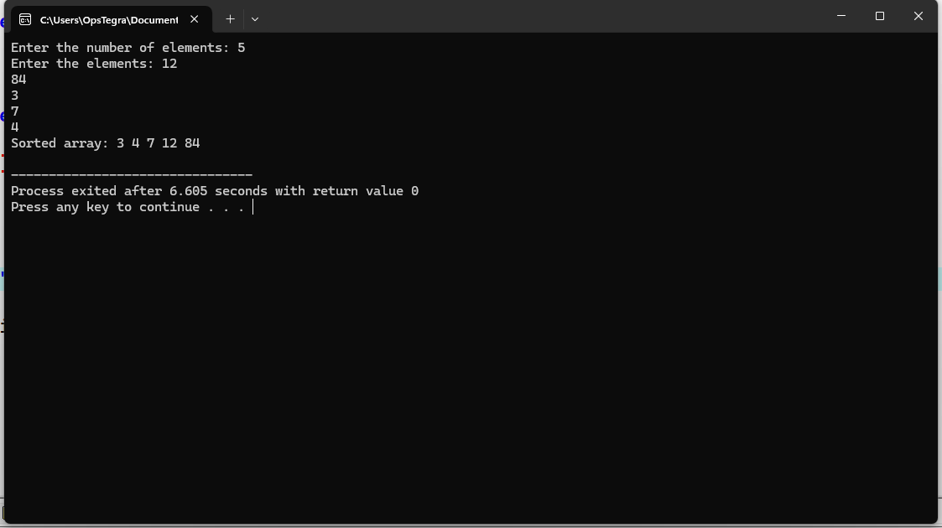

**QUESTION-8:**  
**CODE:**

#include <stdio.h>

void displayArray(int arr[], int size, int index) {

if (index == size) {

return;

}

printf("%d ", arr[index]);

displayArray(arr, size, index + 1);

}

int main() {

int n;

printf("Enter the number of elements: ");

scanf("%d", &n);

int arr[n];

printf("Enter the elements: ");

for (int i = 0; i < n; i++) {

scanf("%d", &arr[i]);

}

printf("Array elements: ");

displayArray(arr, n, 0);

printf("\n");

return 0;

}

**OUTPUT:**

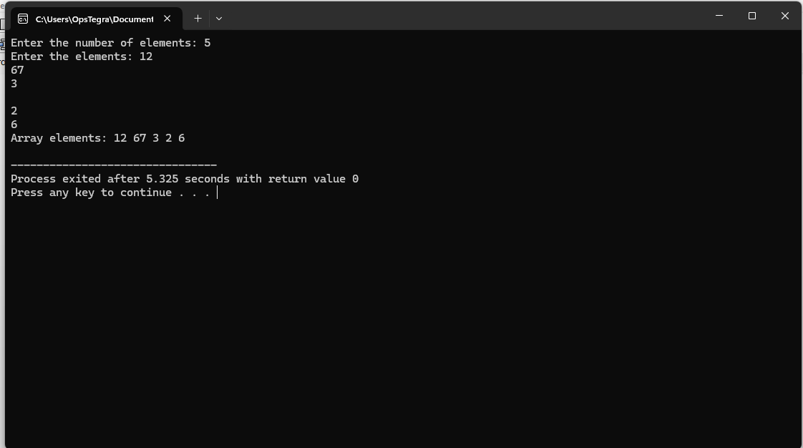  
  
**QUESTION-9:**  
**CODE:**

#include <stdio.h>

struct Employee {

int id;

char name[50];

char department[50];

float salary;

};

void displayEmployeeData(struct Employee employees[], int n) {

for (int i = 0; i < n; i++) {

printf("\nEmployee ID: %d\n", employees[i].id);

printf("Name: %s\n", employees[i].name);

printf("Department: %s\n", employees[i].department);

printf("Salary: %.2f\n", employees[i].salary);

}

}

int main() {

int n;

printf("Enter the number of employees: ");

scanf("%d", &n);

struct Employee employees[n];

for (int i = 0; i < n; i++) {

printf("\nEnter details for employee %d:\n", i + 1);

printf("Employee ID: ");

scanf("%d", &employees[i].id);

printf("Name: ");

scanf("%s", employees[i].name);

printf("Department: ");

scanf(" %s", employees[i].department);

printf("Salary: ");

scanf(" %f", &employees[i].salary);

}

printf("\nEmployee Details:\n");

displayEmployeeData(employees, n);

return 0;

}

**OUTPUT:**

